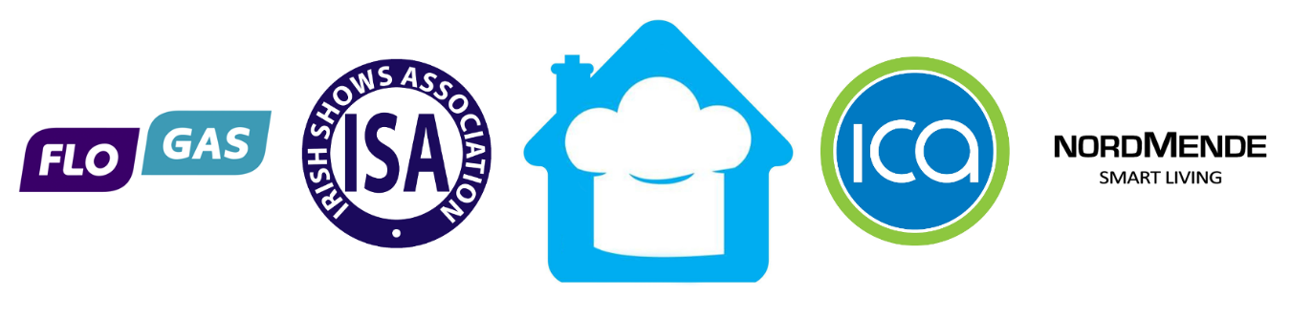

All Ireland Home Cook Champion 2017

Terms and Conditions
Competition entrants must be:
- 18 or over as of 1st May 2017.
- You cannot have acquired any third level or other professional catering qualifications in the last 10 years.
- You cannot have worked full-time as a chef in a restaurant.
- All contestants must be amateur cooks. If you have previous professional kitchen experience that the organisers deem (in their entire discretion) could create an unfair advantage you may not be eligible.
- You must be available to participate in the regional final and the All Ireland final cook off (if chosen), see dates and locations of shows close to you. Final cook-off, All Ireland Final will take place at Iverk Show, Co. Kilkenny Saturday 26th August 2017.

Each entry must consist of:
- A completed application form which includes one full recipe including step-by-step instruction as to how the dish is cooked.
- Entries must be submitted 10 days before each regional final.
Recipe Criteria:
- Entrants must use local produce (all Irish ingredients).
- All recipes should demonstrate creative use of ingredients.
- Preparation and cooking time for the dish must be completed within one hour (this will be applicable also in the regional finals and The All Ireland Final).
For further queries please email johnmartinevent@gmail.com or Tel: 0035387 2681635

